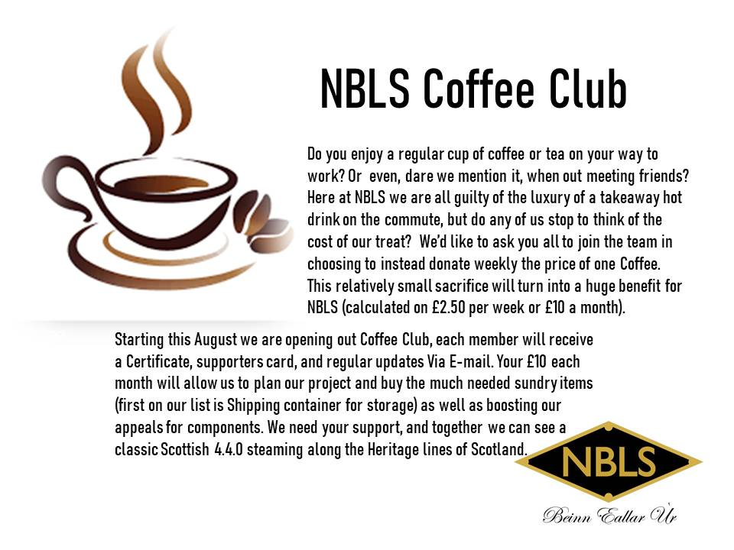Return this section to NBLS
Please complete and hand to one of the NBLS team or post this form to confirm your application to NBLS, 25 Kenilworth Road, Lanark, ML11 7BN
Supporters Details: Name ________________________________
Address____________________________________________________________________Post Code __________________ Contact telephone: ______________________
Email _____________________________________ Signed _____________________
Hand this section to your Bank or Building Society
Standing Order Mandate to donate to NBLS on a monthly basis, you will need to set up a Standing Order with your bank. The details you will require to set this up are as follows:
Bank: Bank of Scotland
Acc. Name: New Build Locomotive Scotland Acc. No: 17561764 Sort Code: 80-22-60 Please use your full name as the reference for the Standing Order. Declaration: I confirm that a Standing Order Mandate has been set up with my bank. Payment will be made to NBLS on a monthly basis, and I consent to being contacted prior to September annually to review my membership.
Signed ____________________ Date _____________ Data Protection: New General Data Protection Regulations came into force on 25 May 2018. We are committed to protecting your personal information, and will not share your details with any organisation outside New Build Locomotive Scotland. Details of your subscription and/or individual donations will be processed solely for our own administrative purposes but may be shared with the Revenue & Customs (HMRC). We will not make contact directly with your sponsors.

